Guide to Train the model

( Download new train.py from drive which I have shared with you or you can incorporate those changes in existing files which I told you earlier through whatsapp)

Initially keep these files and folders in your project root. (Project folder)

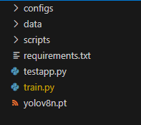

Then run these commands

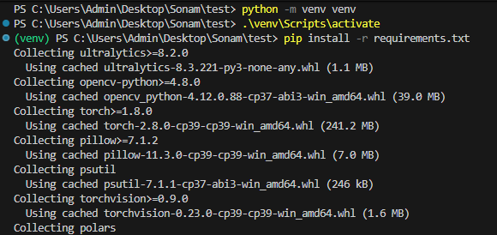

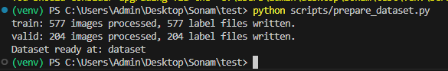

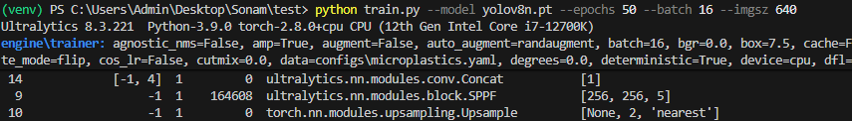

Then training process will start as shown in the image.

